# TFS – GitHub Bridge architecture

## One time setup (per repo)

1. Clone the folder structure of the GIT repo in TFS
2. Go to GitHub repo, authorize TFS sync app

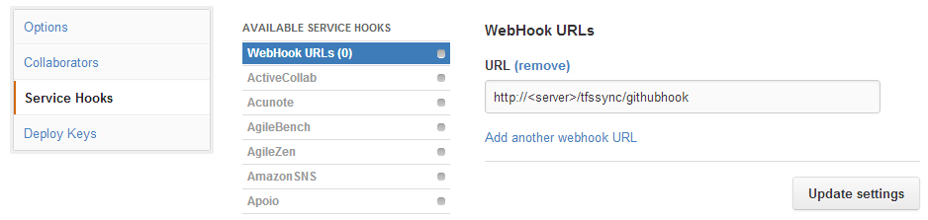

http://<server>/tfssync/githubhook : For DJ’s own GitHub repo (github.dowjones.net), it can be an internal service (IOW, not internet facing) which accepts POST requests.

## TFS GitHub bridge workflow

Once the setup is done, this is how the workflow will look like:

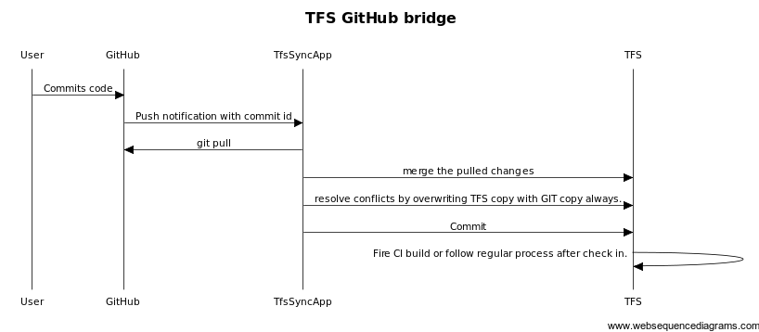

## TfsSyncApp Draft Design

